Sorting in O(n):

n items to sort
n processors

Take in items to compare. Swap/save smaller to local registry, pass larger on to next processor in chain. Take next item, repeat.
- “Sorted in n cpu clocks”
- n² comparisons

If you have n processorsthat all must be interconnected, how many connections do you have?

# Processors  “Fully Connected System”  If decision is to go with “partially connected” instead, then the real question is how to connect. n! possible combinations! -> Physical size vs complexity | # Connections
1 | 0
2 | 1
3 | 3
4 | 6
n | [n(n-1)]/2

Rule of Thumb:

If there are 2+ sections of code that can be executed in any order, it can be done in parallel.
t0
t1 + t0
t2 + t1 + t0
t3 + t2 + t1 + t0
t0
t1 + t0
t2 + t1 + t0
t3 + t2 + t1 + t0
t0
t1 + t0
t2 + t1 + t0
t3 + t2 + t1 + t0
Order does not always matter with respect to which processors do which tasks. However it is not safe to assume that communication channels are infinitely fast!

If the time to split the computations and rejoin is greater than the time to compute on a single processor, it is not really worth it any more.
“Aha! Please take a look; these ideas may be... uh, 'non-kosher'.”:

- Interpretted languages are compiled line by line as they need to be executed. This is slow!
  - Compiled languages are better fpor speed <--> better for parallel processing!
    - Loops, for example, are only translated once.
- Caches are bad!
  - Cache contamination becomes much more likely as number of CPUs increases.
- Virtual memory is slow.
- BUSes are obviously bad and can not be parallelized.
- Recursion is not parallelizable.

Types of Parallelism:

- Covert Parallelism:
  - Parallelism is not visible to programmer, rather extracted by the compiler.
  - Small speedups, typically x10 -x30.
- Overt Parallelism:
  - Parallelism is visible to programmer, and usage of parallel algorithms is facilitated.
  - Large speedups, typically up to and above x1000.

Measures of Parallelism:

Speedup:

Node Efficiency:

, if S represents speedup.

Area Efficciency:

, T_{N} is time taken on N processors, A_{N} is physical area taken by N processors

Is E_{N} > 1 possible? No! -> each CPU running above 100% usage

Goals of Parallel Computing:

- High Performance – exploitation of inherent parallelism
- Fault Tolerance – exploitation of inherent redundancy -> ATM example, to check for errors
- Natural Solution of “Distributed Problems”
- Graceful Degradation and Growth

Types of Computer Architectures:

- SISD – Single Instruction, Single Data
  - Traditional von n Neumann architecture
- SIMD – Single Instruction, Multiple Data
  - Each processor executes synchronously the same instructions using private data
  - Instructions broadcast globally by single control unit
  - Advantages:
    - Single program -> easy programming and debugging
    - Control unit does incrementing and comparing, processors do computing
    - Inherent synchronyzation -> each processor is running same operations
    - Low program memory requirements
    - One decoder in control unit
- MIMD – Multiple Instruction, Multiple Data
  - Each processor executes asychronously it's own instructions using private data
  - Multiple control threads, multiple collaborating programs
  - Advantages:
    - Greater flexibility -> no constraints in operations that can be done concurrently
    - Conditional statements executed more efficiently -> each processor is independant, not waiting on control unit to evaluate all computed data
    - Efficient execution of of longer vs shorter instructions
Ex:
SIMD
p1 p2 p3
MIMD
p1 p2 p3

*Pipelined processors are sometimes incorrectly designated as MISD.
Issues of concern in designing parallel architectures:

- Large register set – decreases delays caused by interrupts
- Large physical address space – decreases delays due to swapping
- Processor scheduling – allows dynamic allocation of processors to tasks
- Processor synchronization (of concern to SIMD only) – prevents processors from simultaneous modification of shared memory locations. Efficient primitives needed to handle synchronization and interrupts
- Interconnection network topology – allows efficient processor-to-processor and processor-to-memory connections (the most expensive component of any supercomputer!)
- Partitioning – identifies parallelism in algorithms to specify the parallel computing streams. Various levels of partitioning are possible – at a statement, procedure, or program levels
- Reliability – refers to graceful degradation of performance and better fault tolerance. As some processors fail, the workload should be picked up by “healthy” processors
- High performance – measured in peak performance or sustained performance

Associative memory is very fast, but expensive.
- Memory contains logic to determine if it caintains data based on providded bit pattern and mask.

Parallel Random Access Machine consists of M memory locations (RAM) shared by P processors

Note the dual role of RAM:
- To store data
- To act as communications area between processors

RAM access primitives:
- Concurrent read (CR) – allows two or more processors to read the same RAM location simultaneously
- Exclusive read (ER) – allows p processors to read simultaneously p distinct RAM locatons
- Concurrent write (CW) - allows two or more processors to write to the same RAM location simultaneously, subject to some protocol (see below)
- Exclusive write (EW) - allows p processors to write simultaneously to p distinct RAM locatons

Bypasses the BUS which is great!

Categories of shared memories:

- Uniform Memory Access model (UMA) – shared memory is centralized. Some central switching mechanism is needed to access memory (bus, or crossbar switch, or or packer-switching network, etc.). When all processors have access to all peripherals, we call it the symmetric multiprocessing system (SMP)
- Non-Uniform Memory Access model (NUMA) – shared memory is distributed and partitioned into a number of modules. Local modules are directly accessible by their processors. Collection of all modules form a global memory accessible to all processors. Processors are allowed simultaneous access to one or more memory modules, and operate independently of each other
- Cache-Only Memory Architecture (COMA) – distributed memories are treated as caches – all caches form a global address space

Interconnection Techniques

Connections are the most expensive supercomputer component!

Fully Interconnected:
- Ideal, usually not possible.... n - 1 connections on each processor, n! total!
Crossbar: (Non-Blocking!)
- Processors criss crossed wired, with switches.
Linear -> Ring -> Mesh -> Torus
Hypercubes:
- each neigherbour only differs by one bit. Makes message passing easy.
Trees -> Fat Trees

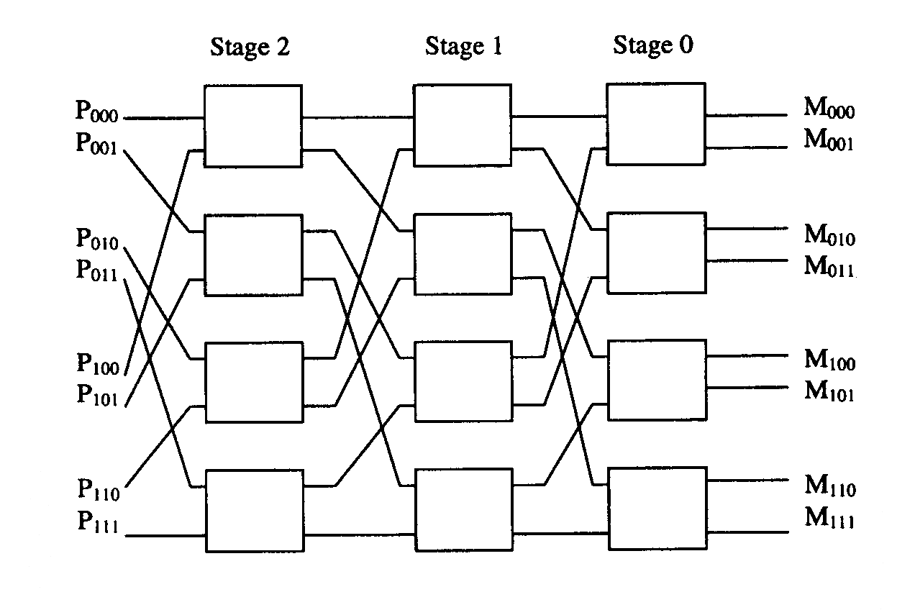
Multistage: (Omega)

Star:
- Each node is center of own star. Size of N, N! processors. N = 4 has 3 connections from each
Parallel Programming Recipe

The process of development of parallel programs can be summarized as follows:
- Pick up a particular problem of interest;
- Conceptualize the solution;
- Split this solution into components to be executed simultaneously as cooperating processes;
- Code each component;
- Arrange components in groups;
- Allocate to each group a separate processor of suitable type;
- Execute simultaneously all components, noting overall run time.

Who do we need groups of processes?

If the number of processes <= number of processors and it is possible to satisfy all processes needs for processor types, then we can allocate each process to a separate processor.

Otherwise, we must have groups of processes with each group being allocated a single processor, and all processes within each group running in a time-sharing mode.
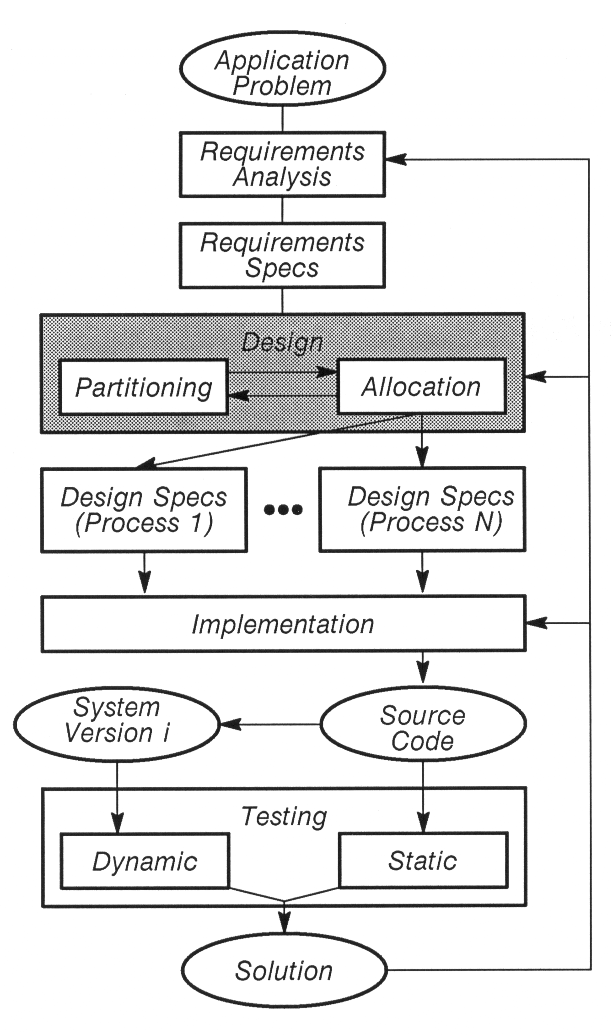
Distributed Software Life Cycle:
Ada Basics:

Everything is tasks. Everything is pass by value/object. Never by reference unless using 'access' (but still is pass by value, just access value).

Sample Ada:
package MyPackage is
procedure MyProcedure (Stuff : Object);
function MyFunction (Stuff : Object) return Object;
task MyTask is
entry MyEntry (X: in Integer; Y: out Integer);
end MyTask;
type Object is record
A : Integer;
B : Boolean;
end record;
type ArrayIndex is range 0..9; -- [0, 9] inclusive on both ends.
type MyArray is array (ArrayIndex) of Object;
end MyPackage;

with Ada.Text_IO; use Ada.Text_IO;
package body MyPackage is
task body MyTask is
loop
select
accept MyEntry (X: in Integer; Y: out Integer) do
-- Stuff
end MyEntry -- end rendezvous
-- Computation outside of rendezvous
or
delay 0.0;
-- Other stuff
end select
end loop;
end MyTask;
procedure MyProcedure (Stuff : Object) is
-- declarations
begin
-- do stuff
end MyProcedure;
function MyFunction (Stuff : Object) return Object is
-- declarations
begin
-- do stuff
return SomeObject;
end MyFunction
begin -- Init
MyObjects : MyArray;
MyObject(0).X := 3;
end MyPackage;

